FOURTH-GENERATION
AI STORAGE APPLIANCE ARCHITECTURE
NeuralMesh • PCIe Fabric • Spectrum-X Ethernet • Intelligent Data Mobility • Zero-Trust Protection • Sovereign Private AI Cloud
A rack-scale, GPU-aware storage platform engineered to sustain AI training, inference, RAG and agentic workloads while protecting sensitive information through encryption, MFA, dynamic authorization, tokenization, pseudonymization and data obfuscation.
REFERENCE DESIGN DOCUMENT
Prepared July 2026

Document Purpose
This document consolidates the architecture, data-path design, intelligent tiering model, cloud integration, resilience controls, embedded zero-trust data-protection algorithm, physical rack and cooling design, performance-optimization roadmap, sovereign private AI cloud architecture, operations control plane and investor positioning for a lightweight fourth-generation AI storage appliance.

Design Objectives
- Feed CPU and GPU clusters with predictable, high-throughput and low-latency access to training and inference datasets.
- Create a unified distributed namespace across high-performance NVMe, dense-capacity flash and cloud-object storage.
- Use workload intelligence to prefetch, promote, demote, compress and protect data without changing application access paths.
- Apply security beyond encryption by incorporating MFA, contextual authorization, data masking, tokenization, pseudonymization and synthetic-data substitution.
- Provide resilient, independently recoverable failure domains with immutable recovery and secure cloud replication.

Contents
1. Architecture vision
2. Logical and physical architecture
3. Technology layers
4. Smart synthetic-intelligence engine
5. Storage hierarchy and data mobility
6. Zero-trust data-protection algorithm
7. Cloud-object security
8. Resilience, operations and performance targets
9. Executive architecture statement

1. Architecture Vision
The appliance combines a distributed NeuralMesh storage fabric, modern PCIe-based NVMe infrastructure, NVIDIA Spectrum-X Ethernet, GPU-aware data services and a policy-driven intelligence layer. It is intended to operate as a unified AI data plane that continuously balances performance, capacity, cost, security and recoverability.
The architecture supports an engineering target of up to 1.1 EB effective capacity per rack, subject to the selected media density, data-reduction ratio, protection policy and workload profile. Capacity and performance figures must be validated during final product qualification.

Logical Architecture
AI COMPUTE AND APPLICATIONS
GPU training • Inference • CPU preprocessing • Kubernetes • RAG • AI agents
▼
AI NETWORK FABRIC
Spectrum-X Ethernet • 400/800 GbE • RoCEv2 • RDMA • GPUDirect-ready data paths
▼
DISTRIBUTED STORAGE FABRIC
NeuralMesh namespace • POSIX • NFS • SMB • S3 • CSI • snapshots • erasure coding
▼
SMART SYNTHETIC-INTELLIGENCE ENGINE
Telemetry • demand prediction • classification • prefetch • tiering • synthetic-data controls
▼
DATA TIERS
DRAM/SCM cache • performance NVMe • dense-capacity flash • encrypted cloud object

Core Architectural Principles
Principle | Design Interpretation
GPU-aware data delivery | Reduce CPU copies and storage bottlenecks through RDMA, GPUDirect-ready access and parallel data paths.
One namespace | Present consistent access across local performance tiers and approved cloud-object targets.
Policy before movement | Classify, authorize, obfuscate and encrypt data before it moves between tiers or clouds.
Independent failure domains | Prevent a switch, controller, enclosure or rack failure from becoming a data-loss boundary.
Security by representation | Return full, masked, tokenized, aggregated or synthetic data according to identity and purpose.

2. Technology Architecture

AI Compute Access Layer
- NVIDIA GPU platforms and CPU-based preprocessing, analytics and orchestration nodes.
- Kubernetes CSI integration for containerized AI pipelines.
- POSIX, NFS, SMB and S3 access through a distributed global namespace.
- GPU-direct or equivalent direct data paths to reduce host CPU overhead.
- Quality-of-service controls that isolate training, inference, checkpoint and metadata traffic.

AI Network Fabric
Use NVIDIA Spectrum-X Ethernet as the primary GPU-to-storage scale-out fabric. The design should support dual, nonblocking network planes and separate compute, storage, management and replication traffic.
Capability | Architecture Requirement
Link speeds | 400/800 GbE server and storage connectivity, with a roadmap for the next Spectrum-X generation.
Transport | RoCEv2 and RDMA with lossless traffic classes.
Congestion management | Adaptive routing, telemetry-driven congestion control and deterministic queue design.
Redundancy | Dual NICs, dual leaf switches and physically independent network paths.
Segmentation | Dedicated VRFs/VLANs or equivalent isolation for compute, storage, management and replication.

PCIe and Storage-Node Architecture
- PCIe Gen 6 deployable for current NVMe controllers, NICs and accelerator connectivity.
- PCIe Gen 7 ready at chassis, backplane, retimer, power and cooling layers.
- Independent PCIe switch and root-complex failure domains.
- Balanced CPU, memory-channel, PCIe-lane and NIC design to avoid internal oversubscription.
- Hot-serviceable media and controller components wherever practical.

3. Smart Synthetic-Intelligence Data Engine
The intelligence engine is the control plane that allows the appliance to “dance” between memory, performance flash, capacity flash and cloud-object storage. It observes access behavior, predicts future demand and applies policy-driven data placement without disrupting applications.

Decision Inputs
Signal | Examples
Workload behavior | Sequential training reads, random vector searches, checkpoint bursts and inference latency.
Data temperature | Recency, frequency, locality and working-set size.
Compute demand | GPU queue depth, model schedule, accelerator utilization and batch windows.
Protection context | Classification, residency, retention, recovery point and legal hold.
Economics | Cost per TB, cloud egress, compression efficiency and reserved capacity.
Risk | Identity risk, anomalous access, exfiltration indicators and destination trust.

Intelligent Actions
- Prefetch datasets before scheduled training or inference execution.
- Promote active blocks to low-latency NVMe and cache frequently accessed metadata.
- Demote inactive datasets to dense-capacity flash or approved cloud-object tiers.
- Apply compression, deduplication and erasure coding according to workload policy.
- Generate privacy-preserving synthetic representations for development, testing and model validation.
- Continuously rebalance capacity and recover from node or enclosure failures.

Data-Mobility Decision Flow
OBSERVE
Collect storage, network, GPU, identity, risk and policy telemetry
▼
CLASSIFY
Identify workload type, data sensitivity, residency and lifecycle state
▼
DECIDE
Select placement, protection, representation and quality-of-service policy
▼
ACT
Prefetch • promote • demote • obfuscate • encrypt • replicate • retain
▼
VERIFY
Check integrity, access outcome, performance and immutable audit evidence

4. Intelligent Storage Hierarchy
SSD and flash should not be treated as distinct media classes because enterprise NVMe SSDs themselves use NAND flash. The architecture therefore distinguishes tiers by latency, endurance, density and placement purpose.
Tier | Technology | Primary Workloads
Tier 0 | GPU memory and host DRAM | Active tensor data, inference state and immediate compute working sets.
Tier 1 | Storage-node DRAM or SCM cache | Metadata, hot blocks, write buffering and low-latency indexes.
Tier 2 | High-performance NVMe SSD | Training datasets, checkpoints, vector indexes and active model files.
Tier 3 | Dense-capacity NVMe flash | Model libraries, historical data and warm datasets.
Tier 4 | S3-compatible object storage | Archive, retained datasets, secondary copies and cost-optimized capacity.

Data-Placement Policy
The data engine evaluates dataset temperature, GPU demand, locality, checkpoint frequency, lineage, cost, recovery requirements and sovereignty. It then prefetches, promotes, demotes or retains data while preserving a stable application namespace.

Protocol and Service Exposure
Interface | Purpose
POSIX / parallel file | High-performance AI training and analytics.
NFS / SMB | Enterprise application, collaboration and legacy access.
S3 API | Object-native AI pipelines, cloud interoperability and archive.
Kubernetes CSI | Persistent storage for containerized AI workloads.
Management API | Automation, provisioning, telemetry, FinOps and policy orchestration.

5. Embedded Zero-Trust Data Protection
The appliance embeds a policy-driven protection algorithm that goes beyond encryption. Every request is evaluated using identity, MFA state, workload identity, device posture, business purpose, data classification, location, behavior and destination risk.

Secure Data Access Flow
IDENTITY VERIFICATION
MFA • device trust • workload identity • certificate validation
▼
POLICY DECISION
Role • attribute • purpose • classification • residency • risk score
▼
DATA PROTECTION
Encrypt • mask • tokenize • pseudonymize • redact • watermark
▼
AUTHORIZED REPRESENTATION
Full data • partial view • aggregate • synthetic data • deny
▼
CONTINUOUS ASSURANCE
Behavior analytics • session revocation • immutable audit • SIEM

Protection Algorithm
1. Verify the user, application or AI agent using MFA or cryptographic workload identity.
2. Calculate contextual risk using behavior, device trust, location, request volume and data sensitivity.
3. Classify the dataset and retrieve its access, privacy, residency and retention policies.
4. Require step-up MFA when risk exceeds the permitted threshold.
5. Deny unauthorized access and write an immutable security event.
6. Obtain a tenant- and session-scoped ephemeral encryption key.
7. Decrypt only authorized data blocks in protected memory.
8. Apply tokenization, masking, redaction, pseudonymization or synthetic substitution at field level.
9. Watermark exports and continuously monitor exfiltration indicators.
10. Revoke the session on anomalous behavior and record the identity, purpose, fields, protection method, risk and destination.

Data Obfuscation Controls
Data Type | Recommended Protection
Social Security number | Tokenization or last-four masking.
Name and address | Pseudonymization with controlled re-identification.
Email address | Deterministic masking for referential consistency.
Financial account | Format-preserving encryption or vaulted tokenization.
Healthcare information | Attribute-level masking and policy-based redaction.
AI training records | Privacy-preserving synthetic substitution.
Production test data | Referentially consistent masking.
Logs and prompts | Pattern-based secret and sensitive-entity redaction.
Vector embeddings | Tenant encryption, namespace isolation and access segmentation.

6. Dynamic Data Views and Synthetic Representation
The same protected dataset can produce different representations according to identity, authorization and business purpose. Production-sensitive values do not need to be exposed to developers, testers or AI training pipelines.
Consumer | Permitted Representation | Example
Privileged data steward | Clear text when explicitly authorized | John Smith | 123-45-6789 | 987654321
Customer-service user | Partially masked values | John S**** | ***-**-6789 | *****4321
AI development environment | Synthetic but statistically representative values | Robert Taylor | 742-81-3956 | 483927105
Analytics consumer | Aggregated or de-identified output | Regional cohort; no direct identifiers
Unauthorized or excessive-risk request | No data returned | Access denied and event logged

Synthetic records should preserve required statistical distributions and referential relationships while maintaining no direct link to the original individual. The generation process should be versioned, measurable and governed as part of the model and data lineage chain.

Enforcement Points
Enforcement Point | Controls
Identity gateway | MFA, workload identity, device trust, session risk and step-up authentication.
Storage namespace | Tenant isolation, ACLs, object policy, classification and least privilege.
Transformation layer | Masking, tokenization, obfuscation, pseudonymization and synthetic substitution.
Cloud transfer gateway | Destination validation, restricted-field removal, encryption and integrity verification.
Monitoring plane | Behavior analytics, anomaly detection, audit evidence and SIEM integration.

7. Secure Cloud-Object Integration
The cloud tier extends the AI-storage namespace and provides archive, retention and secondary-copy capacity. Cloud credentials should be temporary, workload-scoped and issued through federated identity rather than permanently stored on the appliance.

Secure Data Path
AI STORAGE APPLIANCE
Classify • authorize • obfuscate • compress • encrypt
▼
PRIVATE CONNECTIVITY
Direct Connect / ExpressRoute / private service endpoint / IPsec when required
▼
TRANSPORT SECURITY
TLS 1.3 • mutual TLS • signed S3 requests • short-lived credentials
▼
CLOUD OBJECT STORAGE
AWS S3 • Azure Blob • Google Cloud Storage • private S3
▼
ASSURANCE
KMS keys • Object Lock • versioning • checksum • replication • audit

Cloud Movement Policy
- Classify the dataset and validate residency, retention and legal-hold rules.
- Remove, tokenize or pseudonymize restricted fields before movement.
- Apply compression and deduplication where policy permits.
- Encrypt objects with customer-managed keys and establish a private or TLS 1.3 protected path.
- Validate the destination account, bucket, region, object-lock and lifecycle policies.
- Verify checksum, encryption state and object metadata after transfer.
- Write an immutable audit record and preserve lineage between local and cloud copies.

Mandatory Security Controls
Control Domain | Required Controls
Encryption | AES-256 at rest, TLS 1.3 in transit and self-encrypting drives where supported.
Key management | Customer-controlled KMS or HSM keys, rotation and tenant-separated encryption domains.
Platform trust | Secure Boot, hardware root of trust, signed firmware and measured boot.
Access | MFA, RBAC/ABAC, least privilege and just-in-time administration.
Recovery | Immutable snapshots, Object Lock and ransomware-protected recovery copies.
Monitoring | SIEM integration, anomaly detection, exfiltration controls and complete audit trails.

8. Resilience, Operations and Performance

Availability and Recoverability
- Dual power feeds, redundant power distribution and dual management controllers.
- Dual Spectrum-X network planes and independent NIC paths.
- Multiple storage, enclosure and PCIe fault domains.
- Distributed metadata, erasure coding and automated data rebalancing.
- Non-disruptive software and firmware upgrades.
- Immutable local recovery points and cloud or second-site replication.
- Active-active access across multiple AI clusters where required.
A full rack must not be treated as the only recoverability boundary. Critical datasets should remain recoverable from another rack, availability zone, data center or approved cloud-object repository.

Target Engineering Profile
Capability | Architecture Target
Effective capacity | Up to 1.1 EB per rack, subject to data-reduction and protection assumptions.
Raw flash foundation | High-density NVMe media sized during detailed engineering.
Sequential throughput | Multi-terabyte-per-second rack-scale design target.
Random performance | Hundreds of millions of IOPS target, workload dependent.
Compute connectivity | 400/800 GbE Spectrum-X with dual nonblocking fabrics.
Internal interconnect | PCIe Gen 6 deployable and Gen 7 ready.
Availability | No single point of failure and independent recoverability domains.
Access protocols | POSIX, NFS, SMB, S3 and Kubernetes CSI.
Encryption | AES-256 at rest and TLS 1.3 in transit.

Final capacity, IOPS and throughput must be validated against node count, SSD model, compression ratio, read/write mix, metadata intensity, network topology and erasure-coding policy.

Operational Telemetry
- GPU starvation and storage queue latency.
- Throughput, IOPS, cache hit rate and metadata latency.
- Tier-promotion and demotion effectiveness.
- Capacity efficiency, compression and deduplication ratios.
- Cloud egress, object lifecycle and cost-to-serve.
- Authentication risk, masking actions, denied access and anomaly events.
- Recovery-point compliance, snapshot integrity and replication lag.

9. Executive Architecture Statement
The fourth-generation AI Storage Appliance establishes a unified, GPU-aware data fabric that combines NeuralMesh intelligence, high-density NVMe flash, PCIe Gen 6 connectivity with a Gen 7-ready roadmap, and NVIDIA Spectrum-X Ethernet. Its policy-driven synthetic-intelligence engine predicts data demand and dynamically positions datasets across memory, performance flash, capacity flash and encrypted cloud-object tiers. Every data request is evaluated through zero-trust controls that combine encryption, multifactor authentication, contextual authorization, data obfuscation, tokenization, pseudonymization and synthetic-data substitution. The resulting platform provides the throughput, security, availability and data mobility required for large-scale AI training, inference, RAG and agentic-computing environments.

Recommended Next Engineering Deliverables
- Detailed rack-level bill of materials and power/cooling model.
- Nonblocking Spectrum-X leaf-spine port and oversubscription design.
- PCIe lane, root-complex and failure-domain map for each storage node.
- Performance qualification plan for training, checkpoint, RAG and inference workloads.
- Data-classification, masking and synthetic-data policy catalog.
- Threat model, key-management design and cloud trust-boundary assessment.
- High-availability, disaster-recovery and ransomware-recovery test plan.

PART II
PHYSICAL APPLIANCE DESIGN, COOLING AND PERFORMANCE QUALIFICATION
Chassis • Internal Flash Placement • Cooling • Build Procedure • 10.2+ TB/s and 300M IOPS Target

10. Physical Appliance and Cabinet Specification
This section converts the logical architecture into a manufacturing-oriented 48U reference design. It is a preliminary engineering specification. Final mechanical, electrical, thermal, safety, EMC and signal-integrity qualification must be completed with selected vendors before release to production.

10.1 Product Design Objectives
- Rack-scale parallel storage for AI training, inference, RAG, vector search, checkpointing and synthetic-data pipelines.
- Front-serviceable NVMe architecture with independent PCIe, node, network, power and cooling failure domains.
- Dual 400/800 GbE AI Ethernet fabrics and a PCIe Gen 6 production target, with Gen 7 mechanical and thermal readiness.
- Unified namespace across performance NVMe, capacity flash and encrypted S3-compatible object storage.
- Non-disruptive replacement of SSDs, nodes, NICs, fans, power supplies and software services.
- Performance qualification for more than 10.2 TB/s aggregate large-block throughput and up to 300 million 4 KB random-read IOPS per fully populated rack.

10.2 Cabinet Mechanical Specification
Attribute | Reference requirement
Rack format | EIA-310 compatible 19-inch, 48U preferred
External width | 600-800 mm
External depth | 1,200-1,400 mm
Static load rating | At least 2,000 kg
Dynamic load rating | At least 1,500 kg
Doors | At least 80% perforated; split rear door or active rear-door heat exchanger
Grounding | Protective-earth bonding bus and equipment bonding straps
Cable entry | Top and bottom; isolated power, data and liquid paths
Service access | Front SSD service; rear power, network and cooling service
Security | Lockable doors and side panels; door-open sensing
Seismic option | Anchoring kit and site-specific qualification
Target populated mass | Approximately 1,200-2,000 kg, configuration dependent

10.3 Reference Rack Zoning
Rack zone | Indicative placement | Purpose
U48-U43 | Dual Spectrum-X switches, management switches, optical distribution | Shortest network cable paths and top-of-rack serviceability
U42-U39 | Two cloud gateways and three control/metadata nodes | Quorum, policy, orchestration and secure cloud transfer
U38-U16 | Performance storage nodes | Low-latency TLC NVMe and high-bandwidth data path
U15-U7 | Meshed flash/capacity shelves | Dense NVMe capacity and east-west flash fabric
U6-U1 | PDUs, cooling manifold/CDU interface, sensors and service area | Power, coolant distribution and low-center-of-gravity equipment

11. Internal SSD Placement and Meshed Flash Architecture

11.1 Performance Storage Node Layout
Each 1U or 2U performance node should contain 24 front-access E3.S, E3.L or qualified U.2/U.3 enterprise NVMe SSDs arranged as four independent six-drive banks. The banks must map to separate PCIe roots or switches so a single root-complex failure does not remove all media or both network paths.
Component | Per-node requirement
Processors | Dual server-class CPUs; 64-128 physical cores total
Memory | 1-2 TB ECC DDR5
NVMe media | 24 enterprise drives, front-access and hot-swappable
Flash banks | 4 banks x 6 SSDs
Storage network | 4 x 800 GbE for maximum-performance model; 2 x 400/800 GbE for standard model
Boot | 2 mirrored enterprise M.2 NVMe SSDs
Security | TPM 2.0, Secure Boot, signed firmware, hardware root of trust
Cooling | High-static-pressure front-to-rear airflow plus direct liquid cooling for high-power silicon
Serviceability | Independent replacement of drive, fan, PSU and NIC modules

CPU / PCIe Root A CPU / PCIe Root B
├─ Flash Bank A: 6 NVMe SSDs ├─ Flash Bank C: 6 NVMe SSDs
├─ Flash Bank B: 6 NVMe SSDs ├─ Flash Bank D: 6 NVMe SSDs
├─ 2 x 800 GbE interfaces ├─ 2 x 800 GbE interfaces
└─ Independent I/O queues └─ Independent I/O queues

11.2 SSD Physical Placement Rules
- Place all hot-swap SSD bays at the front of each storage node for online replacement without disturbing network or liquid connections.
- Group SSDs into four visually and electrically identifiable banks, with separate power domains, temperature telemetry and PCIe routing.
- Provide dedicated airflow channels between drive banks and prevent bypass using sealed baffles.
- Keep high-endurance metadata and write-log media physically separated from dense QLC capacity media.
- Distribute parity and erasure-code stripes across drives, banks, root complexes, nodes and rack fault domains.
- Place network adapters near their assigned PCIe root complex and use the shortest qualified trace path.
- Maintain service loops and blind-mate connections without blocking fan replacement or coolant isolation.

11.3 Meshed NVMe Flash Layer
The flash mesh is a logical, distributed flash fabric rather than a single physical sheet of memory. Every node contributes NVMe media, memory cache, queue-processing capacity and network paths. The storage software stripes and serves data concurrently across the rack, minimizing hop count and avoiding a centralized controller bottleneck.
GPU / CPU Clients
│
Dual Spectrum-X Fabrics
│
┌──────┼─────────┬─────────┬─────────┐
Node 1 Node 2 Node 3 Node 4 ... Node 32
A B C D A B C D A B C D A B C D A B C D
Distributed NVMe Flash Mesh
- Direct parallel paths from clients to the node holding each data stripe.
- RDMA/RoCEv2 and zero-copy transfer to minimize CPU overhead.
- NUMA-aware queue assignment and PCIe locality.
- Distributed metadata sharding and in-memory metadata caching.
- Automated prefetch, promotion and pinning for scheduled GPU jobs.
- Asynchronous cloud tiering kept outside the critical read/write path.

11.4 3D Internal Design View
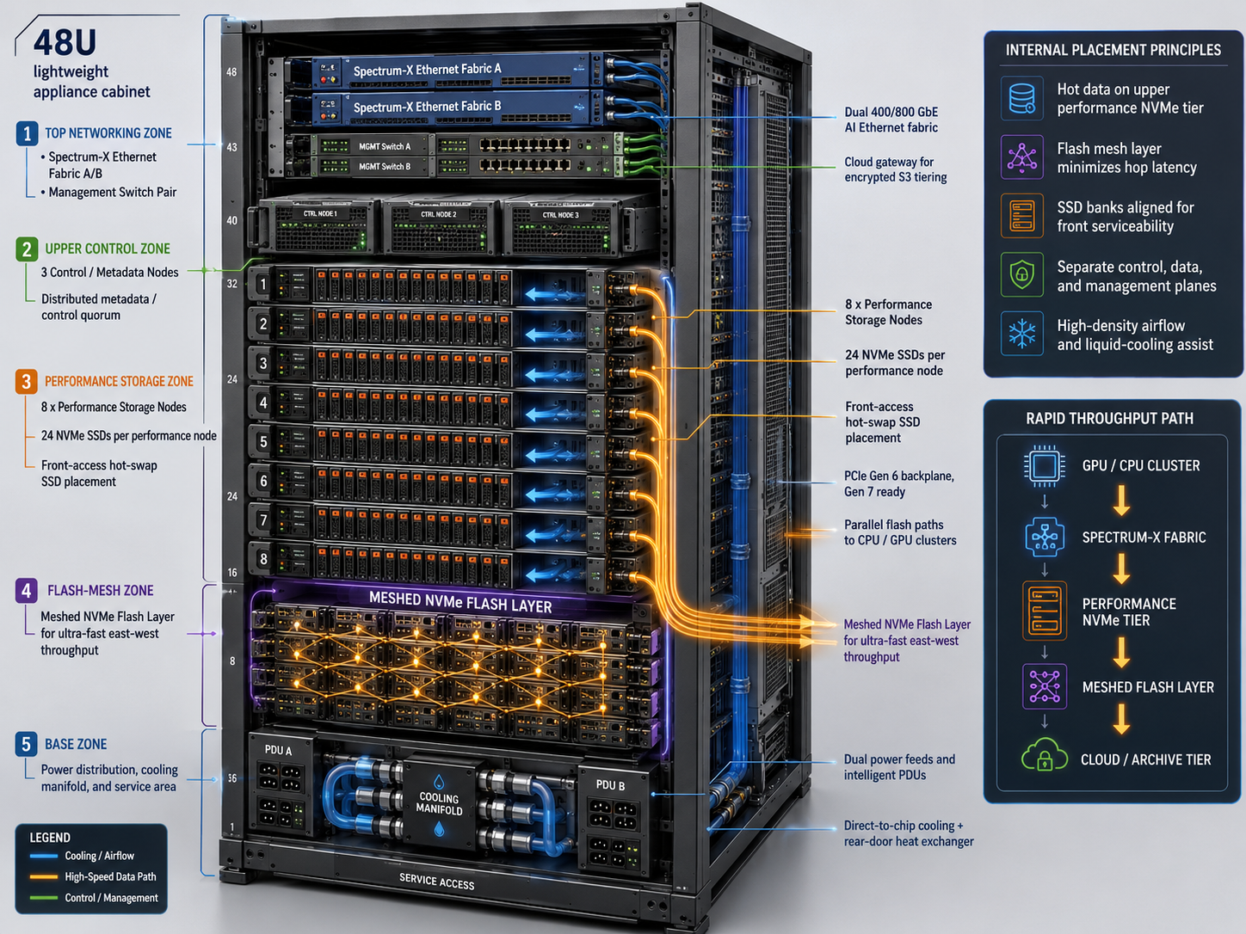
Figure 1. Conceptual 3D cutaway of the 48U AI storage appliance showing network, control, performance NVMe, meshed flash, cooling and power zones.

12. Multi-Layer Cooling and Thermal Cabinet Design
Cooling the external casing alone cannot efficiently remove heat from CPUs, NICs, PCIe switches, memory and SSDs. The recommended design uses three coordinated layers: direct-to-chip liquid cooling, a rear-door heat exchanger and a double-wall thermal cabinet jacket for residual heat stabilization.

12.1 Cooling Architecture
Layer | Coverage | Role
Primary: direct-to-chip | CPUs, high-power NICs, PCIe switches and optional accelerators | Remove concentrated heat at the source
Secondary: rear-door heat exchanger | SSD, DIMM, VRM, motherboard and PSU exhaust | Capture residual air-cooled heat before it enters the room
Tertiary: cabinet coolant jacket | Side panels, top panel and optional cooled SSD rails | Stabilize internal ambient temperature and absorb residual heat

Facility Water → Liquid-to-Liquid CDU → Cabinet Supply Manifold
├─ Direct-to-Chip Branch (highest priority)
├─ Rear-Door Heat Exchanger Branch
├─ Left and Right Microchannel Panel Branches
├─ Top-Panel Branch
└─ Optional Cooled SSD-Rail Branch
Cabinet Return Manifold → CDU Heat Exchanger

12.2 Double-Wall Cabinet Jacket
Element | Preliminary specification
Outer skin | 1.5-2.0 mm powder-coated steel or aluminum
Coolant layer | Bonded/extruded microchannels, approximately 6-12 mm overall panel depth
Channel width/depth | Approximately 4-8 mm wide and 3-6 mm deep
Channel spacing | Approximately 15-30 mm
Coolant velocity | Approximately 0.5-1.5 m/s
Branch pressure drop | Target less than 50-70 kPa
Connections | Rear-edge dripless quick disconnects and isolation valves
Monitoring | Supply/return temperature, flow, differential pressure and leak sensing
Validation | CFD, structural proof pressure, fatigue and corrosion qualification required

12.3 Dew-Point and Temperature Control
The design must not attempt to refrigerate the cabinet to extremely low temperatures. Coolant below room dew point can create condensation and electrical failure. The minimum coolant supply temperature shall remain above measured dew point by a configurable safety margin.
Minimum coolant supply temperature = measured room dew point + 2°C to 5°C safety margin
Parameter | Preliminary target
Secondary-loop supply | Approximately 18-25°C
Secondary-loop return | Approximately 25-35°C
Server inlet air | Approximately 18-27°C
Cabinet inner skin | Approximately 20-30°C
Cooling redundancy | N+1 pumps and fans; dual power feeds
Leak response | Automatic branch isolation, alerting, workload migration and staged shutdown

12.4 Liquid Safety and Materials
- Use CDU-isolated treated water or a qualified water-glycol mix where freezing exposure exists.
- Use stainless steel, copper, nickel-plated copper or qualified protected aluminum; avoid uncontrolled galvanic combinations.
- Install dripless couplings, branch isolation valves, drip trays, leak cable and reservoir-level monitoring.
- Prioritize coolant flow to direct-to-chip branches; cabinet-wall cooling must never starve processor or NIC cold plates.
- Insulate supply pipes and any surface that could approach dew point using fire-rated closed-cell insulation.

13. Hardware, Software and Network Build Requirements

13.1 Reference Rack Bill of Materials
Item | Reference quantity
48U high-density cabinet | 1
Performance storage nodes | 8 standard; up to 32 for maximum performance
Capacity/flash-mesh shelves | 8-16, configuration dependent
Control and metadata nodes | 3 minimum; 5 at larger scale
Cloud gateway nodes | 2 minimum, active-active
Spectrum-X storage switches | 2 independent fabrics
Management switches | 2
Intelligent PDUs | A and B; 2N preferred
Rack CDU or coolant interface | 1, where liquid cooling is used
Environmental sensor package | 1
Spare SSDs | 2-5% of installed media
Spare NICs and optics | At least one NIC per type and 5% optics

13.2 Software Stack
Layer | Required capabilities
Hardened operating system | Enterprise Linux, Secure Boot, measured boot, SELinux, signed modules, immutable or image-based deployment
Distributed storage | Parallel namespace, POSIX/NFS/SMB/S3/CSI, erasure coding, snapshots, clones, quotas, QoS and automated rebalance
AI data services | Prefetch, pinning, tier placement, GPU-aware I/O, synthetic-data services and lineage
Security | MFA, RBAC/ABAC, tokenization, masking, pseudonymization, encryption, immutable audit and SIEM integration
Cloud integration | S3, Azure Blob, GCS/private S3, private endpoints, resumable transfer, object lock and lifecycle policies
Observability | Prometheus-compatible metrics, Redfish, syslog, power/thermal telemetry, SSD endurance and predictive failure analytics
Lifecycle | Rolling upgrades, signed firmware baseline, rollback, SBOM and vulnerability management

13.3 Network Planes
Plane | Connectivity | Function
AI storage fabric | Dual 400/800 GbE, RDMA/RoCEv2, ECN, adaptive routing | GPU/CPU data access and high-bandwidth east-west movement
Cluster/control | Dual 25/100 GbE | Quorum, orchestration, metadata and internal service traffic
Management | Dual 1/10/25 GbE, isolated | BMC, PDU, switch, CDU, sensor and privileged administration
Cloud/replication | 100/200/400 GbE | Encrypted object tiering, site replication and protected backup

14. Physical Assembly and Software Build Procedure

14.1 Cabinet and Hardware Assembly
- Inspect, level, anchor and ground the cabinet; validate floor loading and service clearances.
- Install A/B PDUs, rack sensors, cable-management channels and optional CDU/manifold.
- Install heavy capacity shelves at the bottom, performance nodes in the central zone and switches at the top.
- Connect every device to separate A and B power paths and document outlet mapping and phase balance.
- Connect each storage node to both independent storage fabrics and both management paths.
- Connect cooling branches, pressure test, bleed air, validate leak detection and establish thermal baselines.
- Label every rack unit, power circuit, network port, optic, liquid branch and replaceable module.

14.2 Software Commissioning
- Apply approved BIOS, BMC, SSD, NIC, switch, PCIe retimer and PDU firmware baselines.
- Enable Secure Boot, TPM, IOMMU, PCIe AER and approved performance/power profiles.
- Deploy the hardened operating-system image and register nodes with identity, PKI, DNS, NTP and asset management.
- Configure dual-fabric RDMA/RoCEv2, MTU, ECN, queue affinity, VLAN/VRF and failover.
- Create metadata quorum, storage pools, fault domains, erasure coding, snapshots, namespace and quotas.
- Integrate MFA, KMS/HSM, tenant keys, obfuscation policies, immutable logs and SIEM.
- Configure approved cloud endpoints, short-lived credentials, encryption, object lock and transfer-policy controls.
- Execute hardware, performance, security, resilience and thermal acceptance tests before production release.

15. Performance Architecture: 10.2+ TB/s and 300 Million IOPS
The performance figures are feasible as separate rack-level benchmark targets, but they must be tied to exact workload definitions. The throughput target should use large parallel transfers; the IOPS target should use 4 KB random reads with sufficient clients and queue depth. They should not be represented as simultaneously sustainable unless a mixed-workload test demonstrates that result.

15.1 Maximum-Performance Reference Configuration
Component | Maximum-performance model
Performance nodes | 32 x 1U nodes
SSDs | 24 per node; 768 total enterprise NVMe SSDs
Network per node | 4 x 800 GbE
Rack network | 102.4 Tb/s raw aggregate node bandwidth
PCIe | Gen 6 target, multiple independent root complexes
Memory | 1-2 TB ECC DDR5 per node
Metadata | 3-5 dedicated quorum nodes
Target large-block throughput | 10.2-11.5 TB/s aggregate
Target random-read performance | 300-350 million 4 KB IOPS
Estimated rack power | Approximately 70-110 kW, subject to selected hardware
Cooling | Direct-to-chip plus rear-door heat exchanger and cabinet thermal jacket

15.2 Throughput Model
10.2 TB/s x 8 = 81.6 Tb/s required usable bandwidth
32 nodes x 4 interfaces x 800 Gb/s = 102.4 Tb/s raw = 12.8 TB/s raw
12.8 TB/s x 80% end-to-end efficiency = 10.24 TB/s usable
The 80% efficiency assumption must be replaced by measured protocol, encoding, packet, filesystem, erasure-code and client overhead during qualification. A nonblocking dual-fabric design and enough client-side bandwidth are mandatory.

15.3 IOPS Model
300,000,000 IOPS ÷ 32 nodes = 9.375 million IOPS per node
9.375 million IOPS ÷ 24 SSDs = approximately 391,000 IOPS per SSD
The drive-level requirement is within the capability range of modern enterprise NVMe media. The harder constraint is sustaining those operations through software, CPU scheduling, metadata, PCIe, encryption, network queues and protection logic.
I/O size | Bandwidth represented by 300M IOPS
4 KB | Approximately 1.23 TB/s
8 KB | Approximately 2.46 TB/s
16 KB | Approximately 4.92 TB/s
32 KB | Approximately 9.83 TB/s
64 KB | Approximately 19.66 TB/s

15.4 Required Optimizations
- User-space or kernel-bypass I/O, NVMe multiqueue, RDMA/RoCEv2 and zero-copy transfer.
- GPUDirect Storage where supported, NUMA-aware queue assignment and CPU affinity.
- Distributed metadata sharding, in-memory metadata cache and low-contention namespace operations.
- Vectorized erasure coding and hardware-accelerated encryption.
- No synchronous cloud transfer, obfuscation workflow or deep audit processing in the critical data path.
- Large client fan-out with calibrated queue depth, block size and parallel stream count.
- Continuous thermal monitoring to prevent CPU, NIC or SSD throttling.

15.5 Publishable Performance Statement
Up to 10.2+ TB/s aggregate large-block throughput and 300 million 4 KB random-read IOPS per fully populated rack, subject to configuration, client count, queue depth, protection policy and validated workload conditions.

16. Qualification, Acceptance and Release Gates

16.1 Factory and Site Acceptance Tests
Domain | Required tests
Hardware | Memory/CPU stress, SSD endurance and power-loss, PCIe width/speed, NIC bandwidth, hot-swap, firmware and sensor validation
Performance | Sequential and random workloads, metadata, small/large files, POSIX/NFS/S3, checkpoint, GPU direct, cloud archive/recall and degraded-mode tests
Resilience | A/B power loss, switch/NIC/node/SSD/gateway failures, quorum, cooling alarm, controlled shutdown and restart
Security | MFA, unauthorized access, masking, tokenization, key rotation, drive-removal attack, cloud-region policy and immutable-audit tests
Thermal | Maximum sustained load, fan failure, coolant branch isolation, leak response, dew-point control and throttling analysis

16.2 Minimum Acceptance Criteria
Area | Criterion
Availability | No service loss from any single component failure
Network | Full operation after loss of either storage fabric
Power | Full operation after loss of either A or B power feed
Metadata | Quorum remains available after one control-node failure
Security | All persistent user data encrypted; MFA required for privileged access
Obfuscation | Restricted data transformed according to policy and purpose
Cloud | No data moves to an unapproved bucket, tenant or region
Upgrade | Rolling software and firmware upgrade without namespace outage
Thermal | No sustained CPU, NIC or SSD throttling under accepted workload
Performance | Meets contracted benchmark with documented block size, clients, queue depth and protection settings

16.3 Open Engineering Decisions
- Final SSD make, model, capacity, endurance and TLC/QLC ratio.
- Node count, chassis form factor and exact PCIe lane/root-complex map.
- 400 versus 800 GbE production baseline and optical technology.
- Air, rear-door, direct-to-chip and cabinet-jacket cooling mix.
- Raw capacity, erasure-code overhead and effective-capacity assumptions.
- Power envelope, facility voltage, busway/PDU architecture and cooling-water conditions.
- Storage software licensing, cloud-egress model and field-service strategy.
- Regulatory, EMC, safety, supply-chain, FIPS and SBOM certification scope.

Consolidated Engineering Position
The fourth-generation appliance should be built as a set of independent, serviceable performance and capacity failure domains connected by dual AI Ethernet fabrics. Front-access NVMe banks, distributed flash-mesh software, PCIe locality, direct liquid cooling, residual heat capture, zero-trust data protection and asynchronous cloud tiering together create a credible path to exabyte-class effective capacity and rack-level performance exceeding 10.2 TB/s and targeting 300 million 4 KB random-read IOPS. Every headline claim remains conditional on audited, configuration-specific qualification.
PART III
PRIVATE AI CLOUD, OPERATIONS, OPTIMIZATION AND INVESTOR POSITIONING
Sovereign AI Cloud • Hybrid Connectivity • Operational Control • Algorithmic Scale • Investment Thesis

17. Algorithmic Performance Maximization
NeuralMesh G4 uses a coordinated optimization engine to increase usable throughput, random-read performance and effective capacity while respecting physical limits imposed by SSD media, PCIe lanes, memory bandwidth, CPU scheduling and network fabrics. Higher figures are engineering roadmap targets and must not be represented as guaranteed production specifications before audited qualification.
Metric | Qualified Baseline Target | Optimization Roadmap Target
Aggregate throughput | 10.2+ TB/s | 12-15+ TB/s
4 KB random-read IOPS | 300 million | 350-450 million
Effective capacity | Up to 1.1 EB | 1.3-1.8 EB
Predictable-workload cache hit rate | Workload dependent | 96-99% target
Tail latency | Configuration dependent | 20-40% reduction target

17.1 NeuralMesh Optimization Engine
- Adaptive striping selects stripe width, participating nodes, SSD banks, block size and protection groups according to workload type.
- Predictive cache placement and prefetch use training schedules, model access sequences, checkpoint behavior and vector-index locality.
- NUMA-aware scheduling aligns NIC, CPU socket, memory, PCIe switch and flash bank to minimize cross-socket traffic.
- Dynamic queue-depth and block-size control continuously balances latency, IOPS and throughput for each SSD and workload class.
- Parallel path balancing responds to NIC utilization, PCIe pressure, queue occupancy, network congestion, SSD temperature and endurance.
- Content-aware compression, global deduplication, delta checkpointing and intelligent tiering increase effective capacity without placing cloud transfer in the critical I/O path.

17.2 Thermal-Aware Performance Control
The optimization engine treats temperature as a scheduling signal. It can redirect reads to cooler replicas, spread writes across flash banks, temporarily reduce background rebuild and compression activity, increase coolant flow in affected branches and prevent CPU, NIC, PCIe-switch or SSD throttling.

18. Sovereign Private AI Cloud on NeuralMesh G4
NeuralMesh G4 can serve as the central data brain of a sovereign private AI cloud. The platform brings cloud-like self-service, container orchestration, AI services, analytics and governed data access into an organization-controlled environment while preserving ownership of data, models, policies, infrastructure and encryption keys.
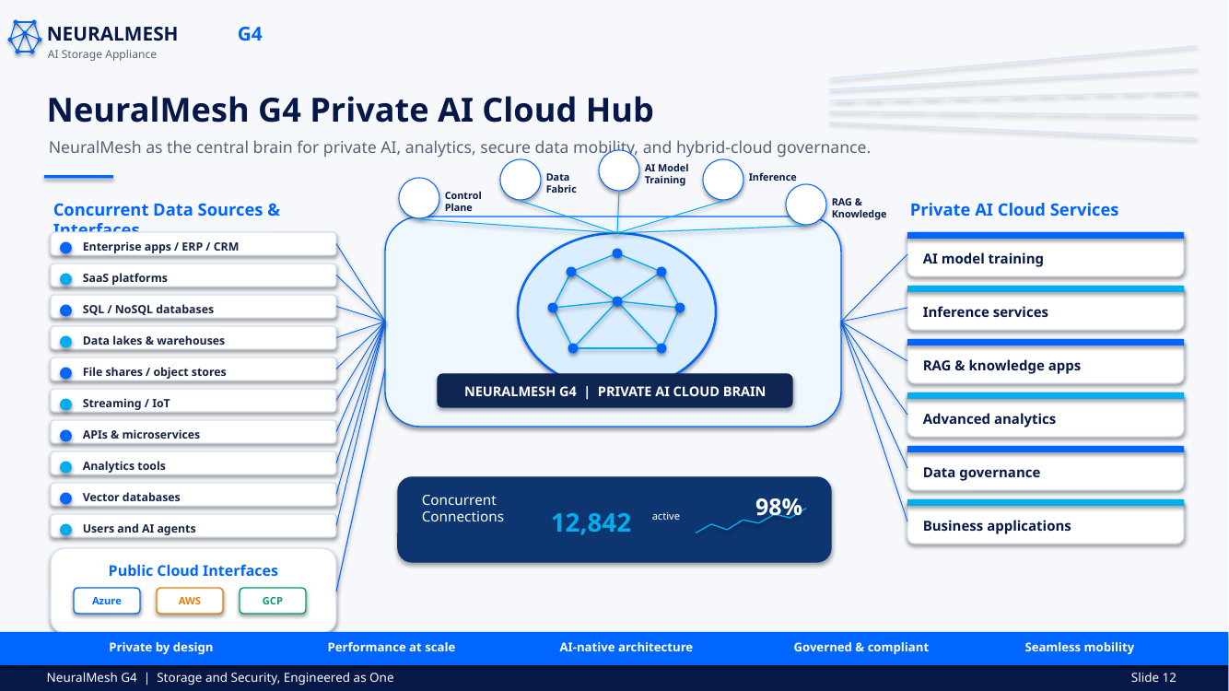
Figure 2. NeuralMesh G4 as the central brain for private AI cloud services and concurrent enterprise data interfaces.
Platform Layer | Required Capabilities
Experience layer | Self-service portal, APIs, notebooks, AI workspaces and developer services
Private cloud control plane | Kubernetes orchestration, tenant and project management, service catalog, quotas, policy and lifecycle automation
AI platform | Training, inference, RAG, agents, vector search, MLOps, LLMOps and model registry
Analytics platform | Lakehouse, SQL, streaming analytics, BI, notebooks, feature services and governed data products
NeuralMesh data fabric | Unified file/object/container namespace, performance NVMe, flash mesh, snapshots and policy placement
Security and governance | Zero Trust, MFA, encryption, masking, tokenization, lineage, retention, residency and immutable audit
Infrastructure | GPU and CPU clusters, Spectrum-X fabrics, storage, power, cooling and observability

18.1 Private AI Cloud Outcomes
- Keep regulated and proprietary datasets within approved organizational or sovereign boundaries.
- Provide cloud-like agility without forcing sensitive data or model assets into public AI services.
- Offer isolated workspaces using masked, tokenized or privacy-preserving synthetic data.
- Operate model training, inference, RAG, analytics and agentic workloads on a governed shared platform.
- Enforce data residency, retention, purpose limitation, model approval and human-oversight policies.
- Extend only approved encrypted copies or workloads to public-cloud services.

19. Hybrid Cloud and Concurrent Data Interfaces
The private AI cloud should support concurrent connections from enterprise applications, AI agents, users and data platforms while exposing policy-controlled interfaces to Microsoft Azure, Amazon Web Services and Google Cloud Platform.
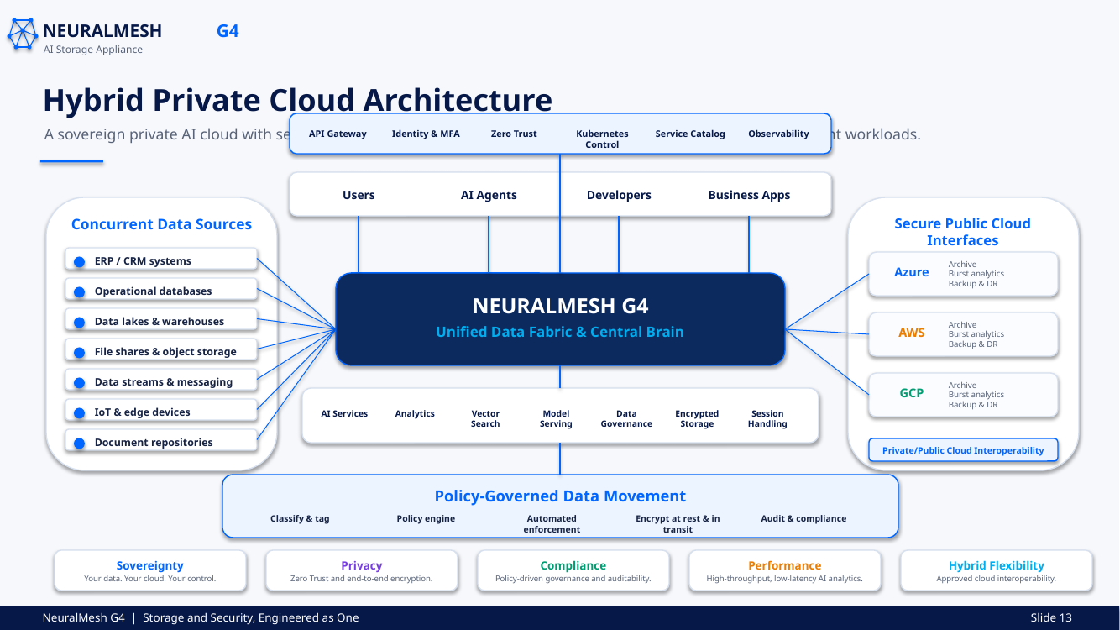
Figure 3. Hybrid private-cloud architecture with concurrent data sources and secure public-cloud interfaces.
Interface Domain | Examples | Control Requirements
Enterprise systems | ERP, CRM, business applications, SaaS | Identity federation, least privilege and workload quotas
Databases | SQL, NoSQL, operational databases and vector databases | Encryption, query policy, masking and audit
Data platforms | Lakes, warehouses, lakehouse, file shares and object stores | Classification, lineage, retention and placement policy
Streaming and edge | Kafka-like streams, messaging, IoT and edge devices | Rate control, schema validation and anomaly detection
Application interfaces | APIs, microservices, notebooks and analytics tools | API gateway, token scopes, service identity and telemetry
Public cloud | Azure, AWS, GCP and private S3 | Approved encrypted archive, burst analytics, backup/DR and destination validation

19.1 Policy-Governed Data Movement
- Classify and tag incoming data, model artifacts, prompts, embeddings and checkpoints.
- Evaluate residency, purpose, retention, legal hold, destination and risk policies.
- Apply masking, tokenization, pseudonymization or synthetic substitution when required.
- Encrypt data at rest and in transit with customer-controlled keys.
- Permit only approved destinations and block unauthorized public-cloud movement.
- Validate checksums, preserve lineage and write immutable audit evidence.

20. Operations Control Panel and Observability
The appliance includes a unified operations control panel that presents storage, data-pipe, performance, cooling, connectivity, security and lifecycle information through one operational view. The dashboard should support role-based views for executives, storage operations, cloud operations, security teams and site-reliability engineering.
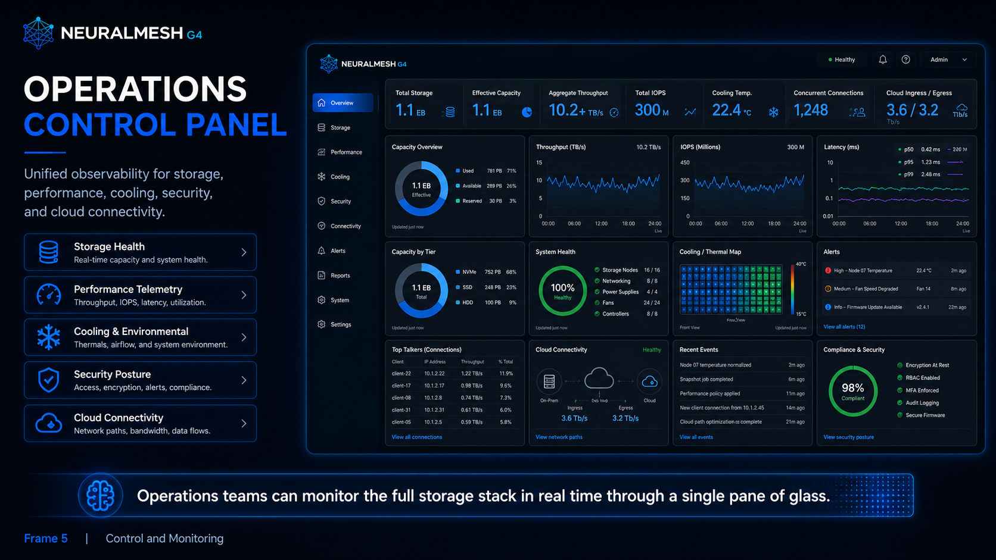
Figure 4. Conceptual operations control panel for storage, performance, cooling, security and cloud connectivity.
Dashboard Domain | Representative Metrics and Controls
Capacity | Raw, usable and effective capacity; utilization by tier; reduction ratio; forecasted exhaustion
Performance | Aggregate throughput, read/write IOPS, p50/p95/p99 latency, queue depth, cache hit rate and metadata latency
Data pipes | Per-fabric, per-node and per-client bandwidth; cloud ingress/egress; packet loss and congestion
Cooling | Inlet, outlet, SSD, CPU, NIC and coolant temperatures; flow, pressure, dew-point margin and thermal map
Connections | Concurrent users, applications, agents, protocols, sessions and top talkers
Security | Vulnerabilities, access denials, MFA state, anomalies, encryption state, firmware compliance and audit health
Cloud connectivity | Azure, AWS, GCP and private-object connections, destination status, transfer jobs and policy exceptions
Reliability | Node, SSD, switch, PSU, fan and controller health; rebuild state; replication lag and active alerts

20.1 Control-Loop Automation
- Correlate performance, thermal and security telemetry before taking automated action.
- Apply bounded remediation such as queue tuning, workload relocation, coolant-flow adjustment and cloud-transfer throttling.
- Require human approval for actions that affect regulated data, retention, encryption keys or destructive recovery operations.
- Record every automated decision, contributing signal, policy and outcome in immutable audit evidence.

21. Investor Thesis and Differentiated Value
NeuralMesh G4 should be positioned as an integrated AI data infrastructure platform rather than a conventional storage array. Its investment proposition is based on the convergence of AI infrastructure demand, data sovereignty, private cloud adoption, security regulation and the need to sustain high GPU utilization.
Differentiator | Why It Matters
Storage and security as one architecture | Protection, representation, policy and audit are embedded in the data path rather than bolted on as separate tools.
Sovereign private AI cloud foundation | Organizations can retain ownership of data, models, policies and keys while delivering cloud-like AI services.
Double-layer thermal design | The coolant jacket, direct-to-chip cooling and rear-door heat capture support sustained dense operation and serviceability.
Meshed NVMe flash and adaptive data paths | Parallel PCIe, flash-bank and network design targets extreme throughput and massive random-read performance.
Algorithmic capacity and performance optimization | Adaptive striping, predictive cache, compression, deduplication and delta checkpointing create a differentiated software value layer.
Hybrid-cloud governance | Approved encrypted mobility to Azure, AWS, GCP and private S3 while restricted data remains inside policy boundaries.
Unified operations control | A single control plane combines storage, cooling, security, connections, vulnerabilities and cloud telemetry.

21.1 Why Invest
- AI infrastructure spending increasingly depends on removing data bottlenecks that leave expensive accelerators underutilized.
- Data privacy, sovereignty and sector regulation are increasing demand for controlled private AI environments.
- The platform addresses multiple budgets: high-performance storage, private cloud, security, data governance, analytics infrastructure and cyber resilience.
- The architecture offers recurring software, support, lifecycle, cloud-integration and managed-service revenue opportunities beyond hardware sales.
- The design is modular, allowing enterprise, AI-factory and exabyte-scale product configurations from a common architecture.
- Performance, security and cooling intellectual property can create defensible differentiation if validated, patented where appropriate and implemented through production-quality software.

21.2 Investor Qualification Requirements
The investment case must be supported by independently validated performance testing, a manufacturable bill of materials, thermal and power qualification, supply-chain agreements, software ownership or licensing clarity, security certification plans, customer design partnerships and a realistic route from reference architecture to production appliance.

22. Product Identity and Strategic Philosophy
Product name: NeuralMesh G4. Positioning: fourth-generation AI storage appliance and intelligent data core for sovereign AI infrastructure.
“Storage and security are not two separate systems. They are one intelligent foundation for trusted AI.”
NeuralMesh G4 — A brainchild of Ramesh Valluri.
Storage and Security, Engineered as One.

Updated Consolidated Engineering Position
NeuralMesh G4 combines a rack-scale meshed NVMe data fabric, dual AI Ethernet networks, PCIe locality, multi-layer cooling, zero-trust protection, private AI cloud services, secure hybrid-cloud interoperability and algorithmic optimization. It is intended to operate as the central data brain for AI training, inference, RAG, analytics and agentic workloads while preserving sovereignty and policy control. Baseline claims remain 10.2+ TB/s aggregate throughput, up to 300 million 4 KB random-read IOPS and up to 1.1 EB effective capacity per rack; higher figures remain qualification-stage engineering targets.

